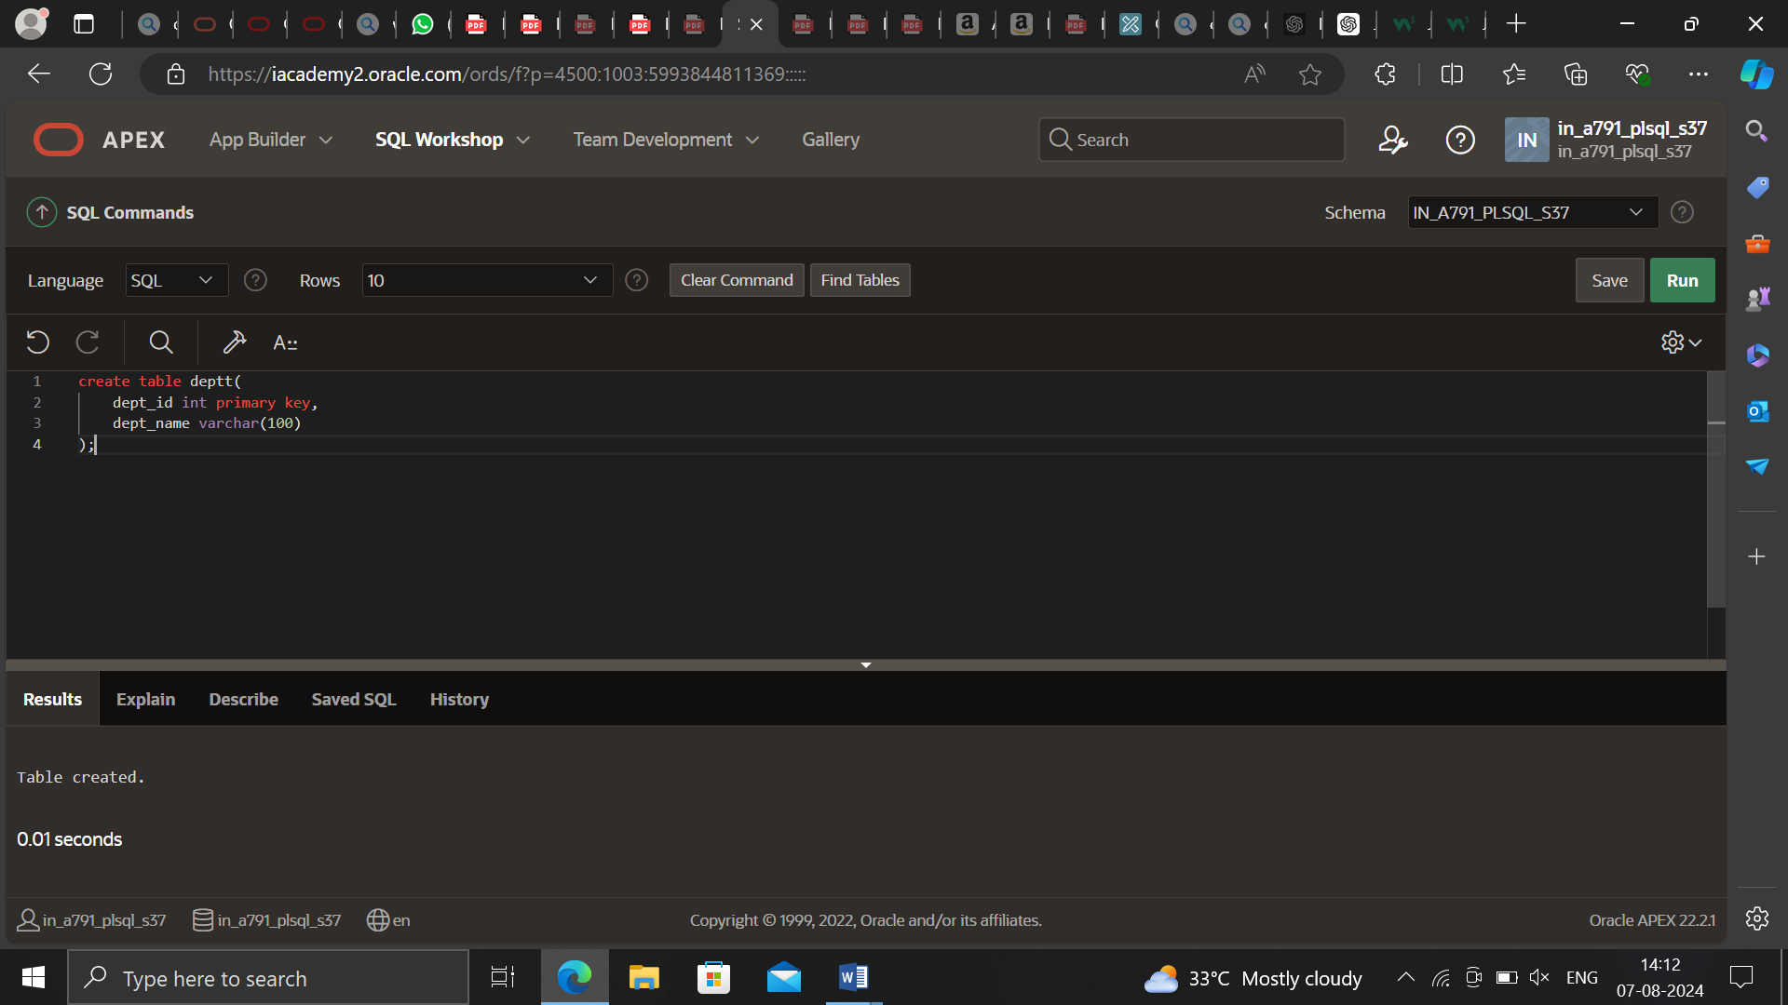

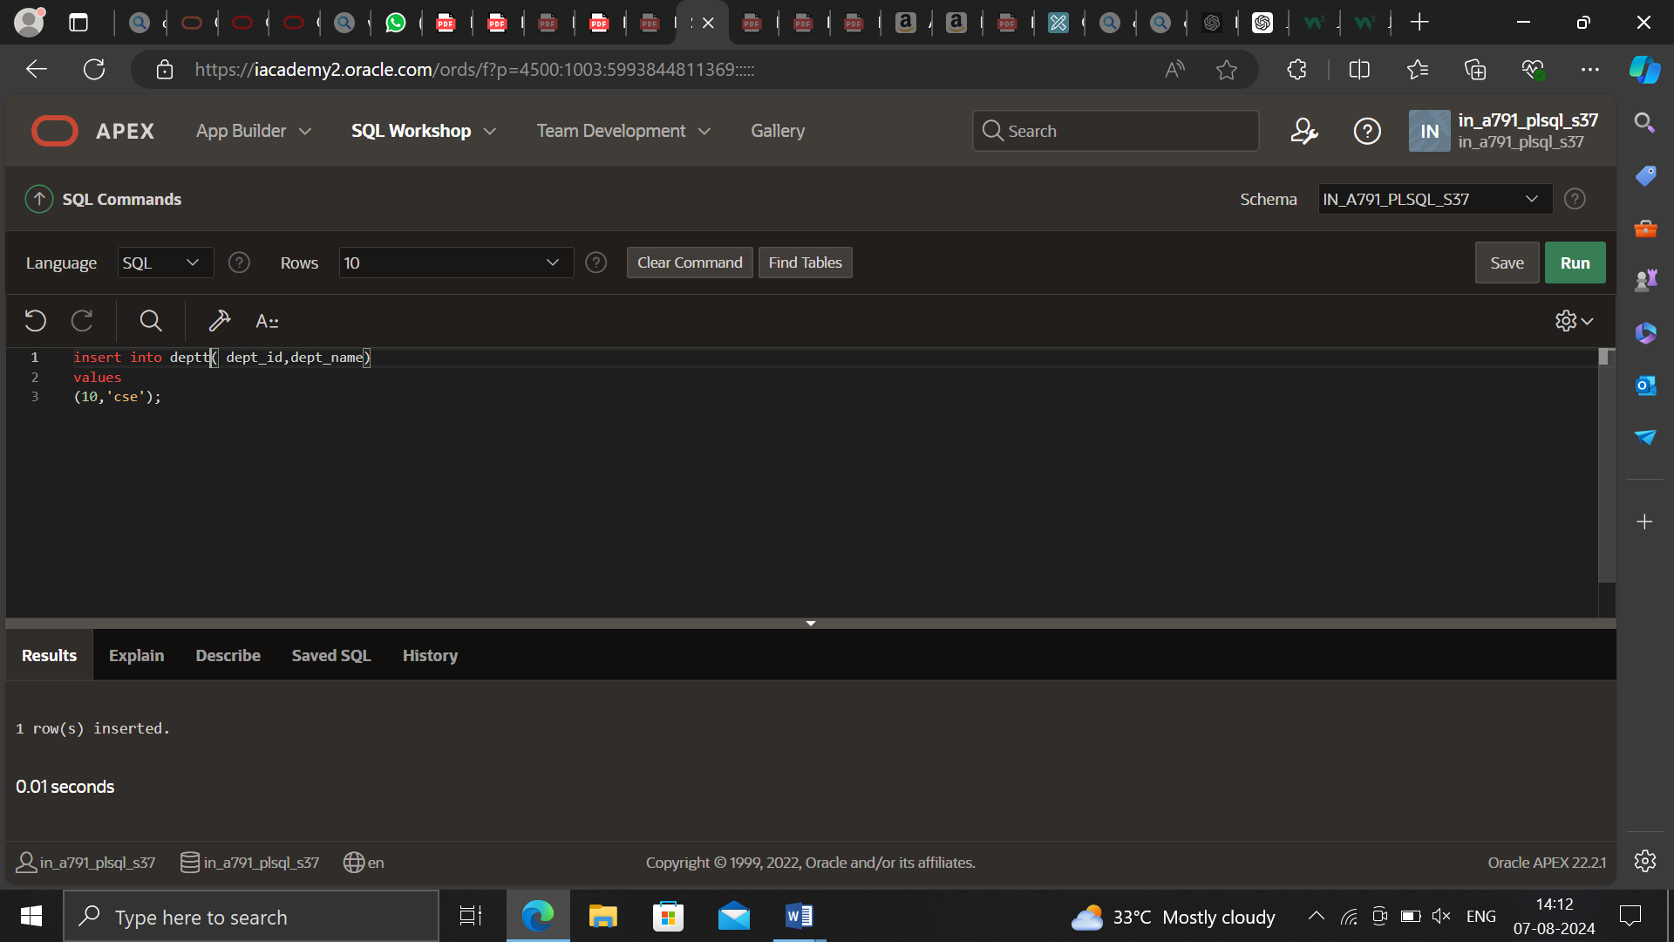

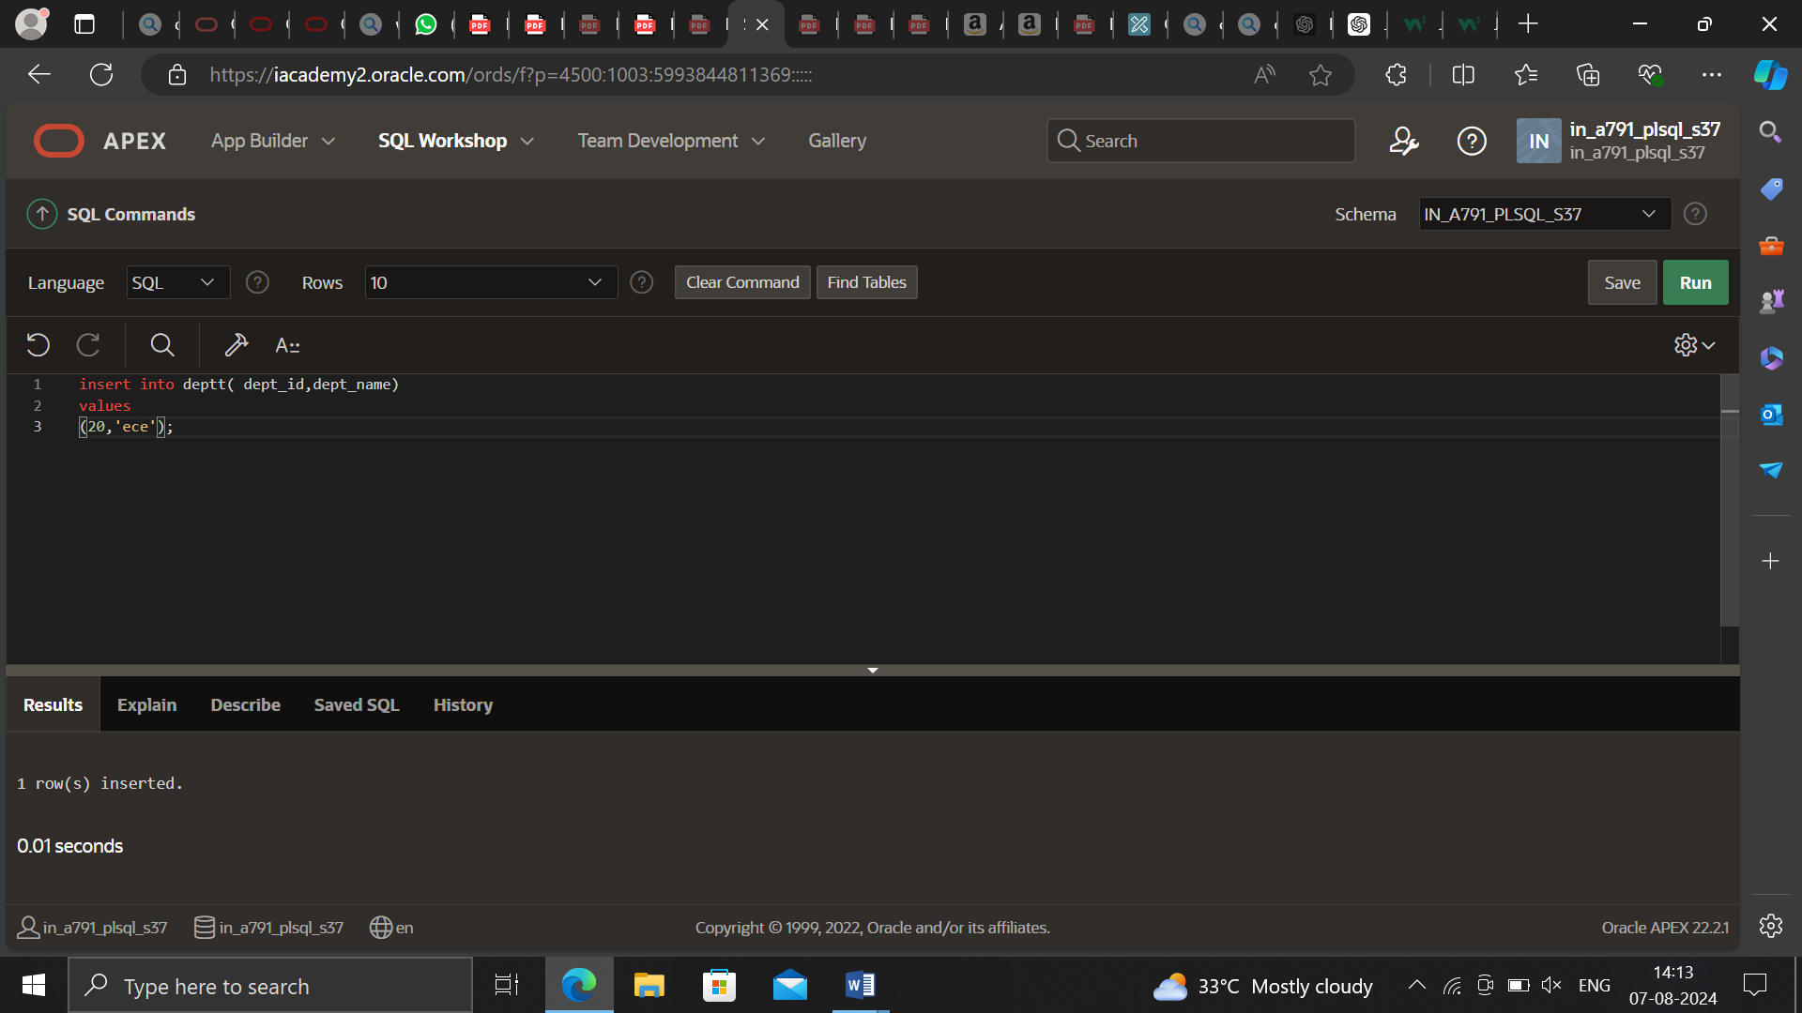

CREATE OR REPLACE PROCEDURE add_dept IS

v_dept_id dept.department_id%TYPE;

v_dept_name dept.department_name%TYPE;

BEGIN

v_dept_id := 280;

v_dept_name := 'ST-Curriculum';

INSERT INTO dept(department_id, department_name)

VALUES(v_dept_id, v_dept_name);

DBMS_OUTPUT.PUT_LINE('Inserted '|| SQL%ROWCOUNT || '

row.');

END;

